6. Show the accounting Equation on the basis of the following transaction: (a) Udit started business with:
(i) Cash Rs. 5,00,000
(ii) Goods Rs. 1,00,000
(b) Purchased building for cash Rs. 2, 00,000
(c) Purchased goods from Himani Rs. 50,000
(d) Sold goods to Ashu (Cost Rs. 25,000) Rs. 36, 000
(e) Paid insurance premium Rs. 3,000
(f) Rent outstanding Rs. 5,000
(g) Depreciation on building Rs. 8,000
(h) Cash withdrawn for personal use Rs. 20,000
(i) Rent received in advance Rs. 5,000
(j) Cash paid to himani on account Rs. 20,000
(k) Cash received from Ashu Rs. 30,000

. Use accounting equation to show the effect of the following transactions of M/s Royal Traders:
(a) Started business with cash Rs.1,20,000
(b) Purchased goods for cash Rs. 10,000
(c) Rent received Rs. 5,000
(d) Salary outstanding Rs. 2,000
(e) Prepaid Insurance Rs. 1,000
f) Received interest Rs. 700
(g) Sold goods for cash (Costing Rs. 5,000) Rs. 7,000
(h) Goods destroyed by fire Rs. 500
(Ans: Assets = Cash Rs. 1,22,700 + Goods Rs. 4,500 + Prepaid insurance Rs. 1,000; Liabilities = Outstanding salary Rs. 2,000 + Capital Rs. 1,26,200)
6. Show the accounting Equation on the basis of the following transaction: (a) Udit started business with:
(i) Cash Rs. 5,00,000
(ii) Goods Rs. 1,00,000
(b) Purchased building for cash Rs. 2, 00,000
(c) Purchased goods from Himani Rs. 50,000
(d) Sold goods to Ashu (Cost Rs. 25,000) Rs. 36, 000
(e) Paid insurance premium Rs. 3,000
(f) Rent outstanding Rs. 5,000
(g) Depreciation on building Rs. 8,000
(h) Cash withdrawn for personal use Rs. 20,000
(i) Rent received in advance Rs. 5,000
(j) Cash paid to himani on account Rs. 20,000
(k) Cash received from Ashu Rs. 30,000
(Ans : Assets = Cash Rs. 2,92,000 + Goods Rs. 1,25,000 + Building Rs. 1,92,000 + Debitors Rs. 6,000 = 6,15,000: Laibilities = Creditors Rs. 30,000 + Outstanding Rent Rs. 5,000 + Rent Rs. 5,000 + Capital Rs. 5,75,000 = Rs. 6,15,000)
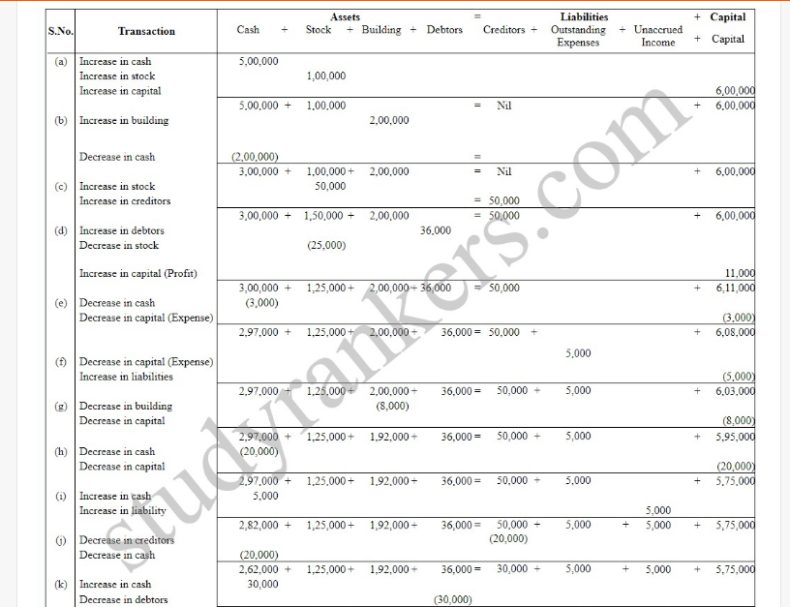
7. Show the effect of the following transactions on Assets, Liabilities and Capital through accounting equation:
(a) Started business with cash Rs. 1,20,000
(b) Rent received Rs. 10,000
(c) Invested in shares Rs. 50,000
(d) Received dividend Rs. 5,000
(e) Purchase goods on credit from Ragani Rs. 35,000
(f) Paid cash for house hold Expenses Rs. 7,000
(g) Sold goods for cash (costing Rs.10,000) Rs. 14,000
(h) Cash paid to Ragani Rs. 35,000
(i) Deposited into bank Rs. 20,000
(Ans: Assets = Cash Rs. 37,000 + Shares Rs. 50,000 + Goods Rs. 25,000 + Bank Rs. 20,000 = Rs. 1,32,000; Liabilities = Capital Rs. 1,32,000)
Journalising 11.
Journalise the following transactions in the books of Himanshu: 2005 Rs.
Dec.01 Business started with cash 75,000
Dec.07 Purchased goods for cash 10,000
Dec.09 Sold goods to Swati 5,000
Dec.12 Purchased furniture 3,000
Dec.18 Cash received from Swati In full settlement 4,000
Dec.25 Paid rent 1,000
Dec.30 Paid salary 1,500
12. Enter the following Transactions in the Journal of Mudit : 2006 Rs.
Jan.01 Commenced business with cash 1,75,000 Jan.01 Building 1,00,000
Jan.02 Goods purchased for cash 75,000 –
Jan.03 Sold goods to Ramesh 30,000
Jan.04 Paid wages 500 Jan.06 Sold goods for cash 10,000
Jan.10 Paid for trade expenses 700
Jan.12 Cash received from Ramesh 29,500 Discount allowed 500
Jan.14 Goods purchased for Sudhir 27,000
Jan.18 Cartage paid 1,000
Jan.20 Drew cash for personal use 5,000
Jan.22 Goods use for house hold 2,000
Jan.25 Cash paid to Sudhir 26,700 Discount allowed 300
13.
Journalise the following transactions: 2005 Rs.
Dec. 01 Hema started business with cash 1,00,000
Dec. 02 Open a bank account with SBI 30,000
Dec. 04 Purchased goods from Ashu 20,000
Dec.06 Sold goods to Rahul for cash 15,000
Dec.10 Bought goods from Tara for cash 40,000
Dec.13 Sold goods to Suman 20,000
Dec.16 Received cheque from Suman 19,500
Discount allowed 500
Dec.20 Cheque given to Ashu on account 10,000
Dec.22 Rent paid by cheque 2,000
Dec.23 Deposited into bank 16,000
Dec.25 Machine purchased from Parigya 10,000
Dec.26 Trade expenses 2,000
Dec.28 Cheque issued to Parigya 10,000
Dec.29 Paid telephone expenses by cheque 1,200
Dec.31 Paid salary 4,500
14. Jouranlise the following transactions in the books of Harpreet Bros.:
(a) Rs.1,000 due from Rohit are now a bad debts.
(b) Goods worth Rs.2,000 were used by the proprietor.
(c) Charge depreciation @ 10% p.a for two month on machine costing Rs.30,000.
(d) Provide interest on capital of Rs. 1,50,000 at 6% p.a. for 9 months. 86 Accountancy
(e) Rahul become insolvent, who owed is Rs. 2,000 a final dividend of 60 paise in a rupee is received from his estate.
15. Prepare Journal from the transactions given below :
(a) Cash paid for installation of machine Rs. 500
(b) Goods given as charity Rs. 2,000
(c) Interest charge on capital @7% p.a. when total Rs. 70,000 capital were
(d) Received Rs.1,200 of a bad debts written-off last year.
(e) Goods destroyed by fire Rs. 2,000
(f) Rent outstanding Rs. 1,000
(g) Interest on drawings Rs. 900
(h) Sudhir Kumar who owed me Rs. 3,000 has failed to pay the amount. He pays me a compensation of 45 paise in a rupee.
(i) Commission received in advance Rs. 7,000 Posting
16 Journalise the following transactions, post to the ledger: 2005 Rs.
Nov. 01 Business started with (i) Cash 1,50,000
(ii) Goods 50,000 Nov. 03 Purchased goods from Harish 30,000 Nov. 05 Sold goods for cash 12,000 Nov. 08 Purchase furniture for cash 5,000 Nov. 10 Cash paid to Harish on account 15,000
Nov. 13 Paid sundry expenses 200
Nov. 15 Cash sales 15,000 Nov. 18 Deposited into bank 5,000
Nov. 20 Drew cash for personal use 1,000
Nov. 22 Cash paid to Harish in full settlement of account 14,700
Nov. 25 Good sold to Nitesh 7,000
Nov. 26 Cartage paid 200
Nov. 27 Rent paid 1,500
Nov. 29 Received cash from Nitesh 6,800 Discount allowed 200
Nov. 30 Salary paid 3,000

